Sunshine Vitamin Sunlight is main source of  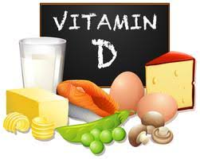  Food Source  Cheese, margarine, butter, fortified milk, healthy cereals, and fatty fish  The sun is the ideal way to get vitamin D, since we can’t always count on the sun it is important to get vitamin D from Diet and supplements.  Milk is number one source of vitamin D in the American Diet.  The recommendations:  - 1-2-year-old children is 16 oz (2-3 cups) of whole milk.  - 1-5-year-old children is 16 oz (2-3 cups) of low-fat milk.  This can provide 75% of the daily value of daily value of vitamin D.  Need a supplement to reach the body needs.  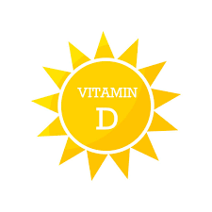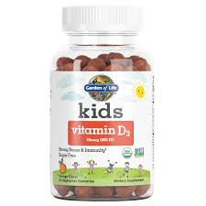  mliy Health Car Centern WIC office | Benefits of Vitamin D  Essential for normal growth development  Important for formation and maintenance of bone and teeth  Help the absorption of phosphorus and calcium  Prevent from many diseases.  RDI  vITAMIN d recommendation  INFANTS: 10 MCG (400 iu)  CHILDREN: 15 mcg (600 IU)
This institution is an equal opportunity provider.

