Weekly Evaluation
Afnan Chikhani
Fontbonne University

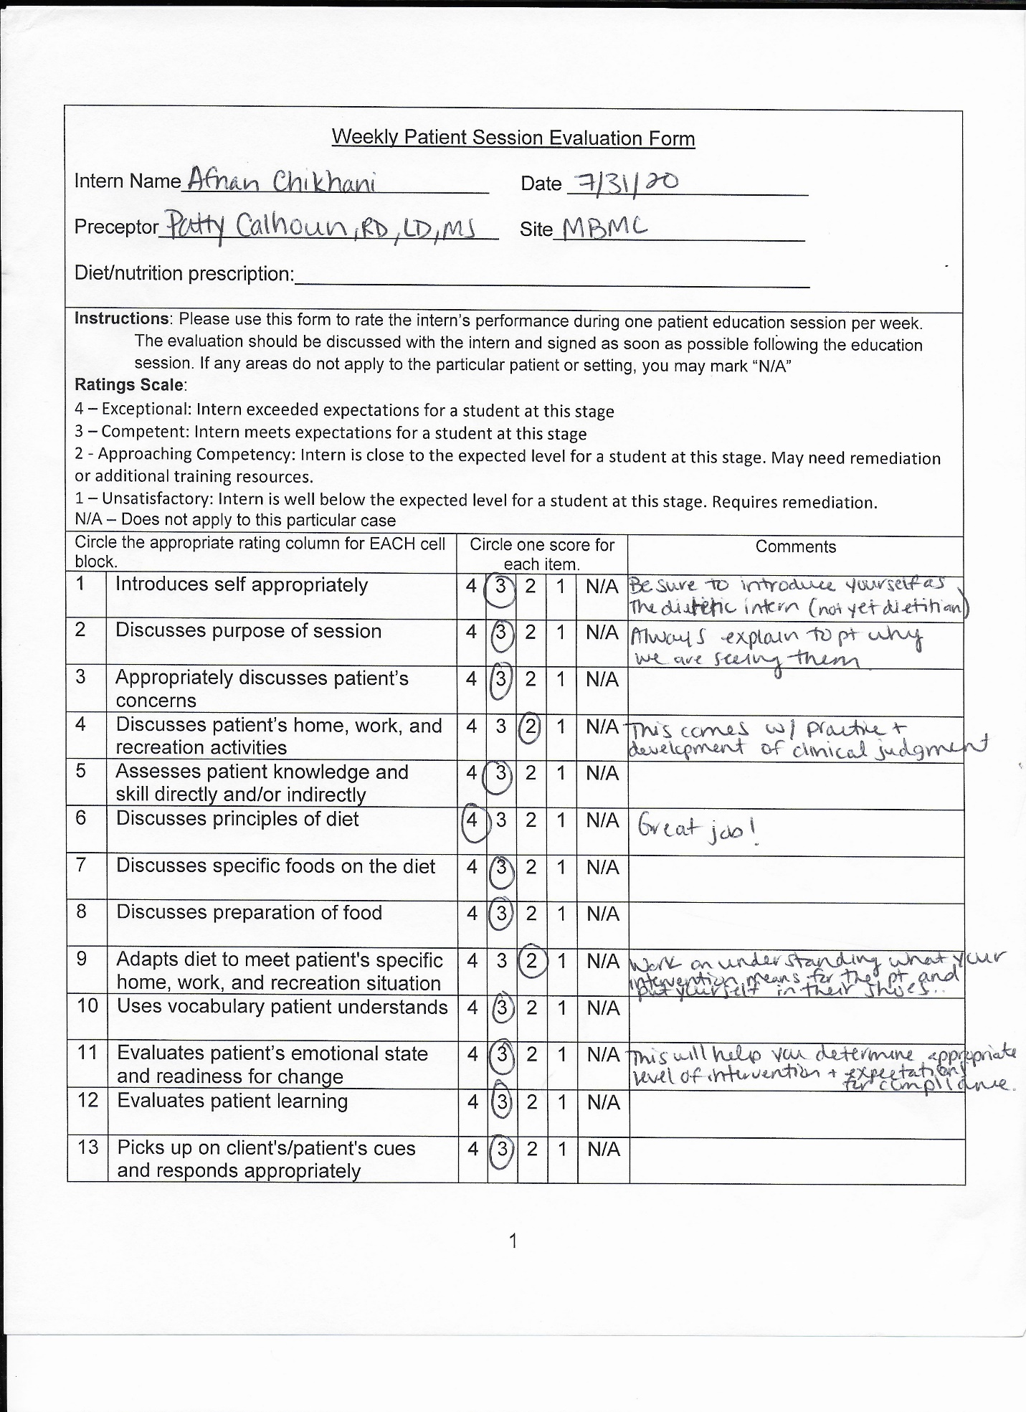
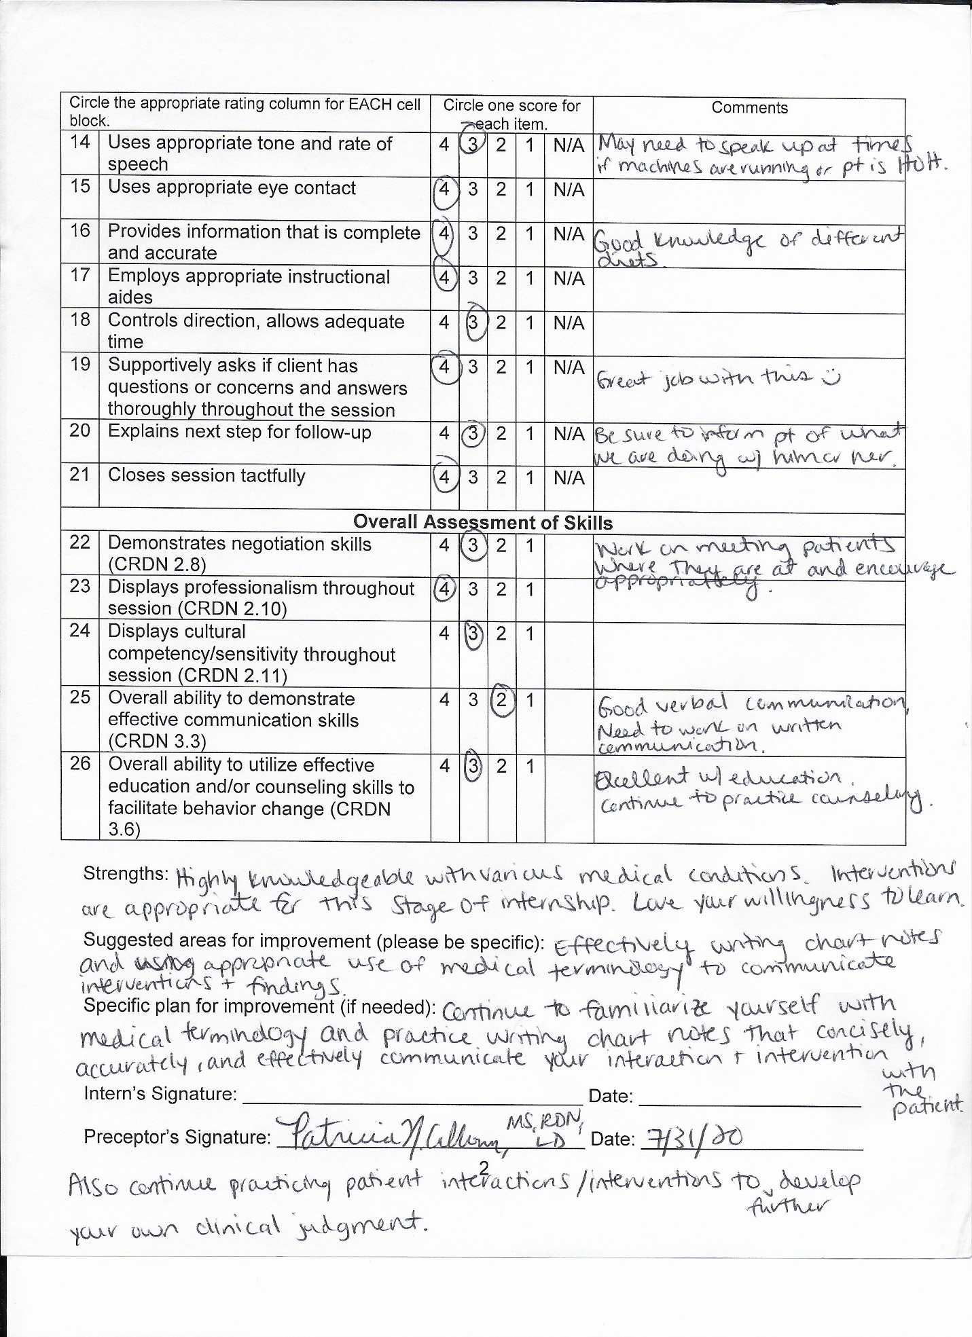
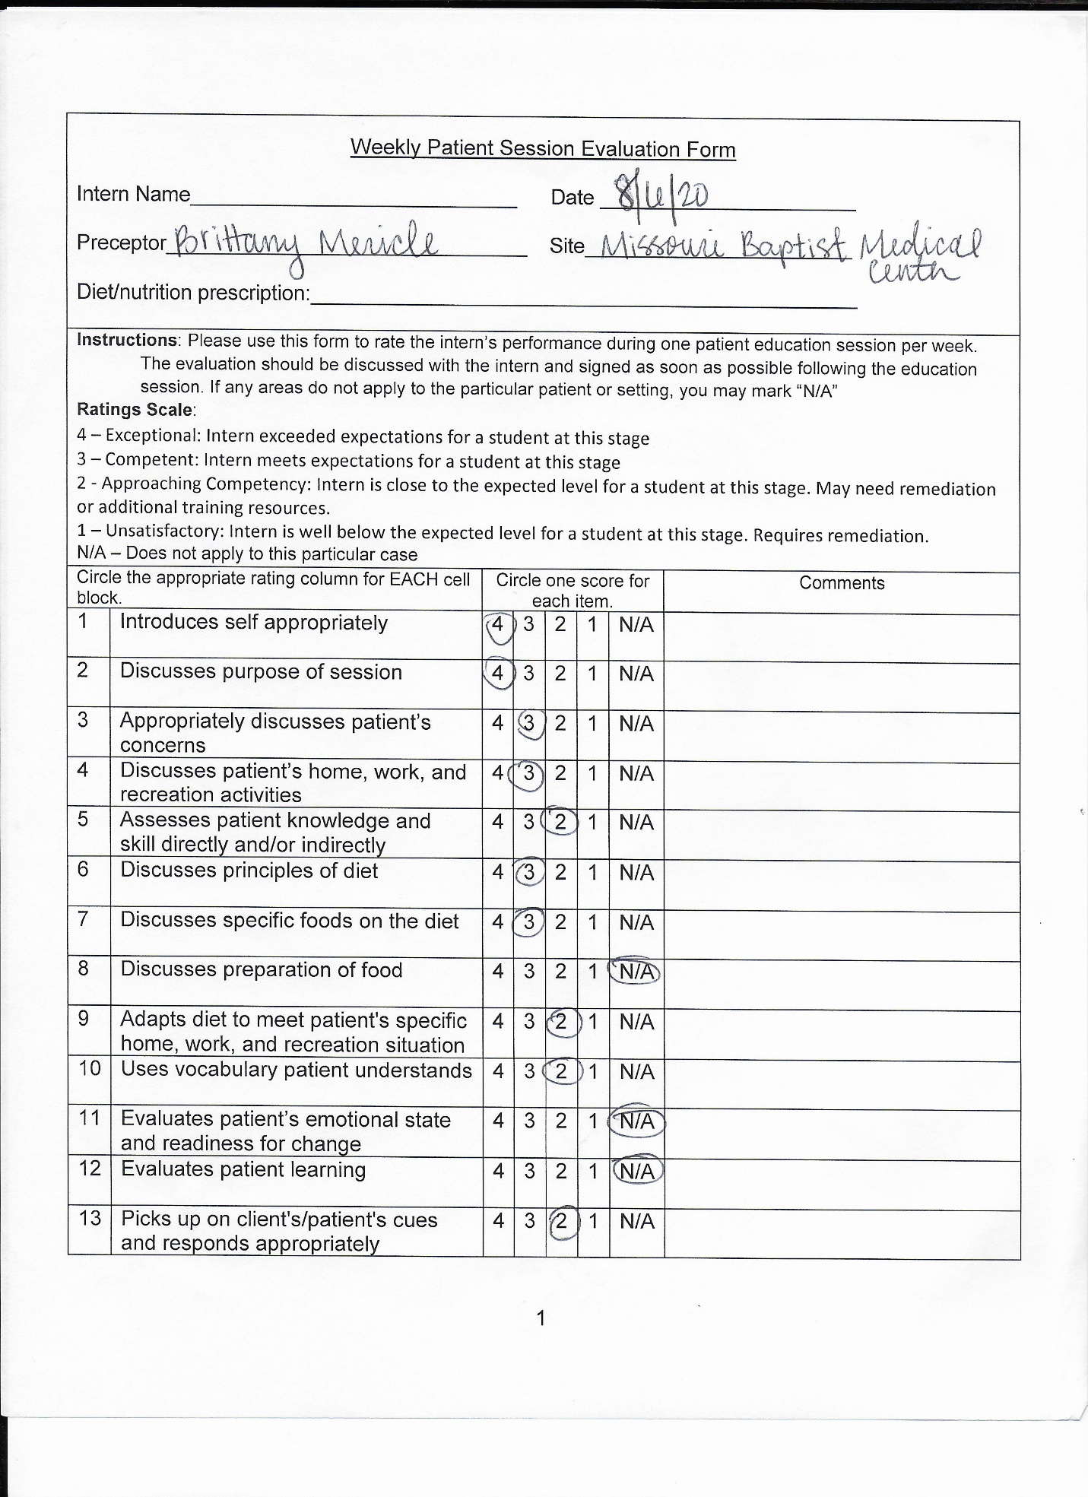
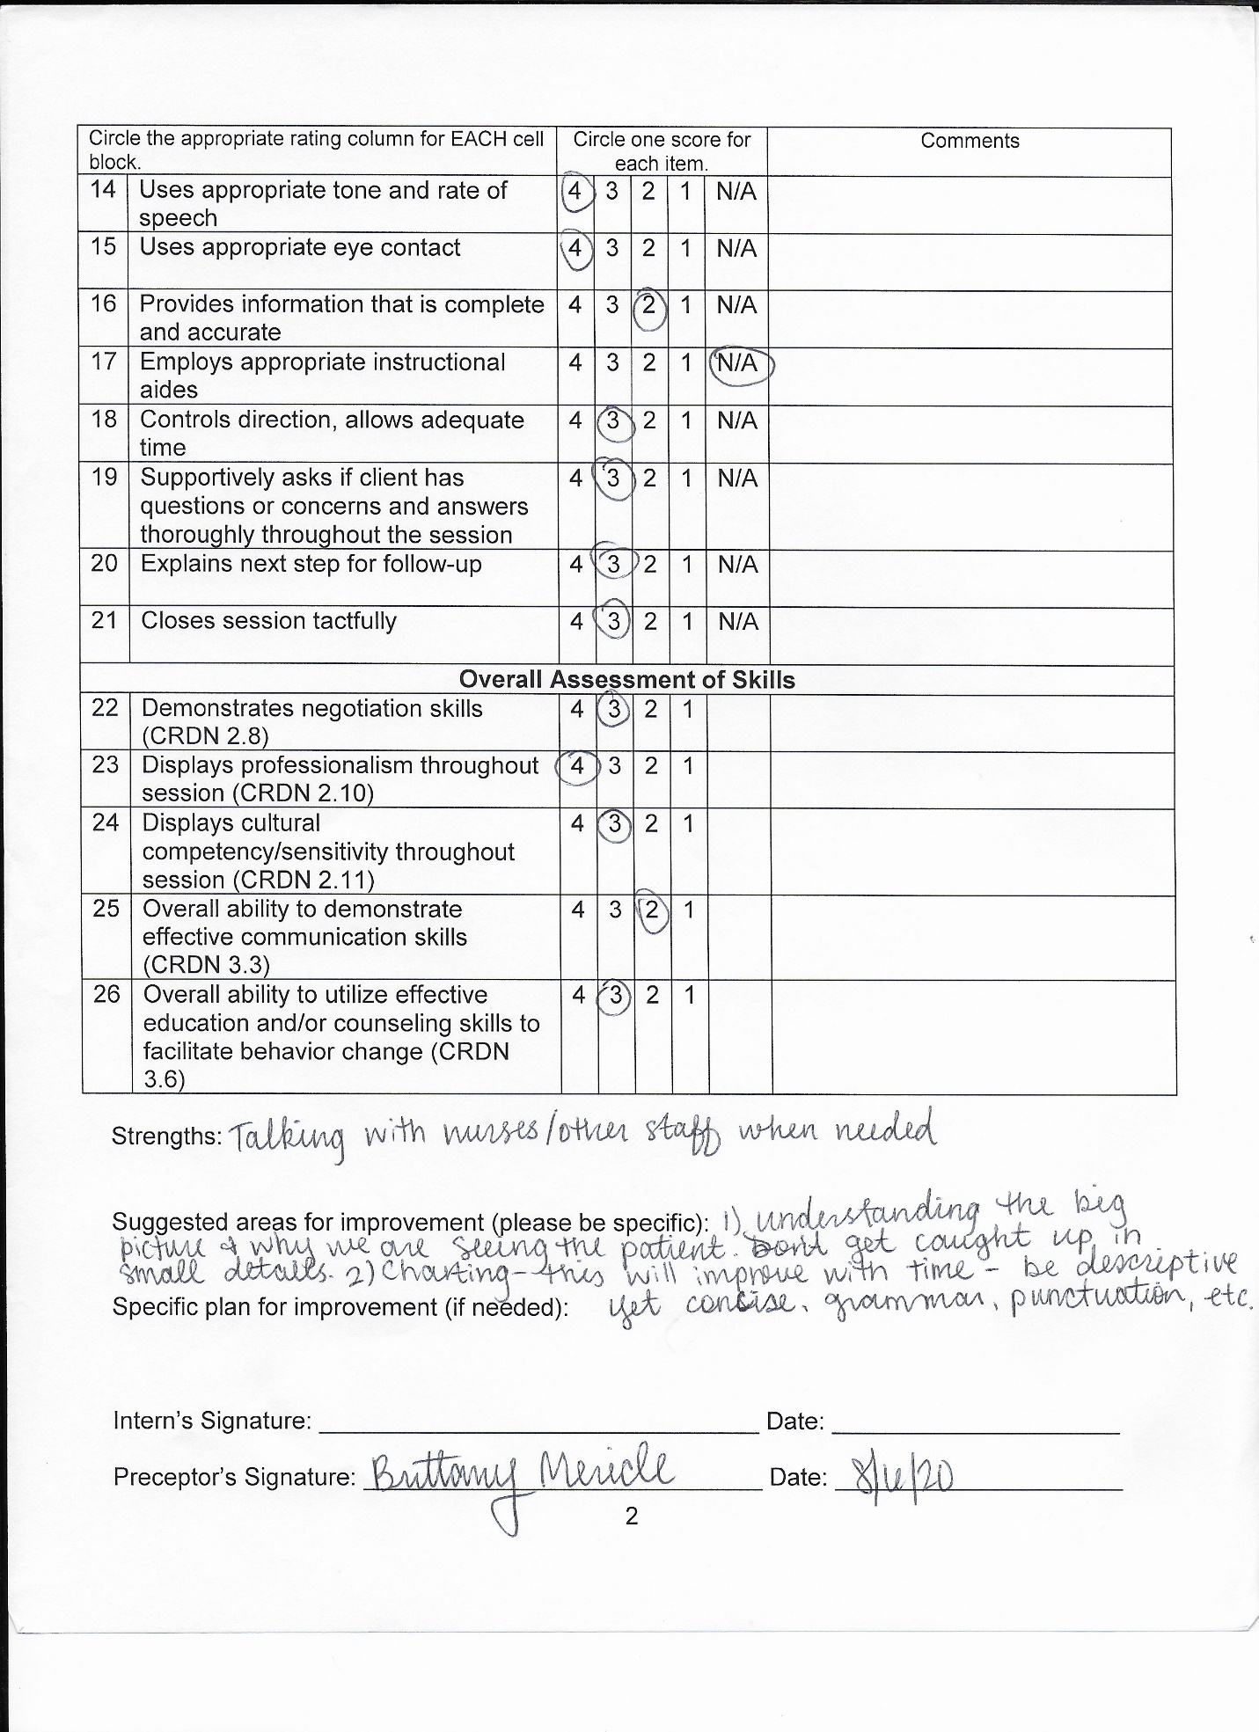
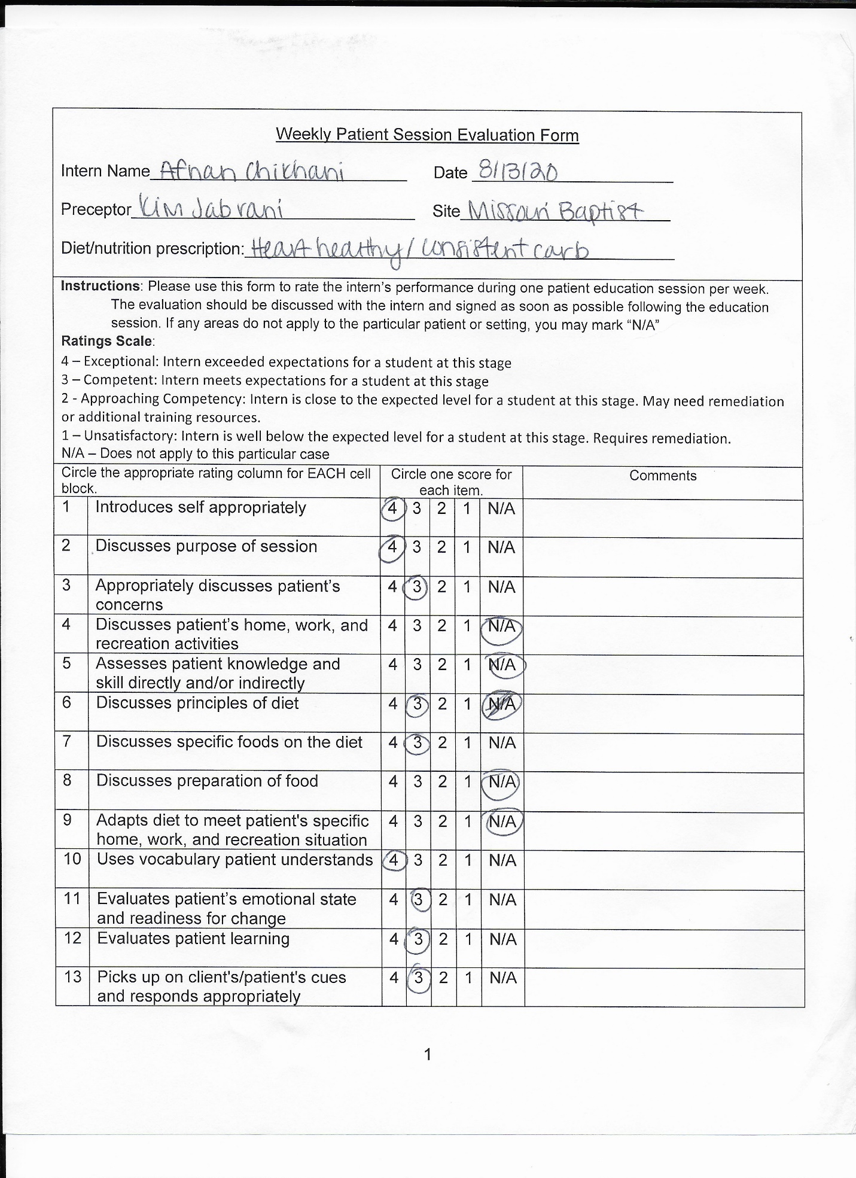
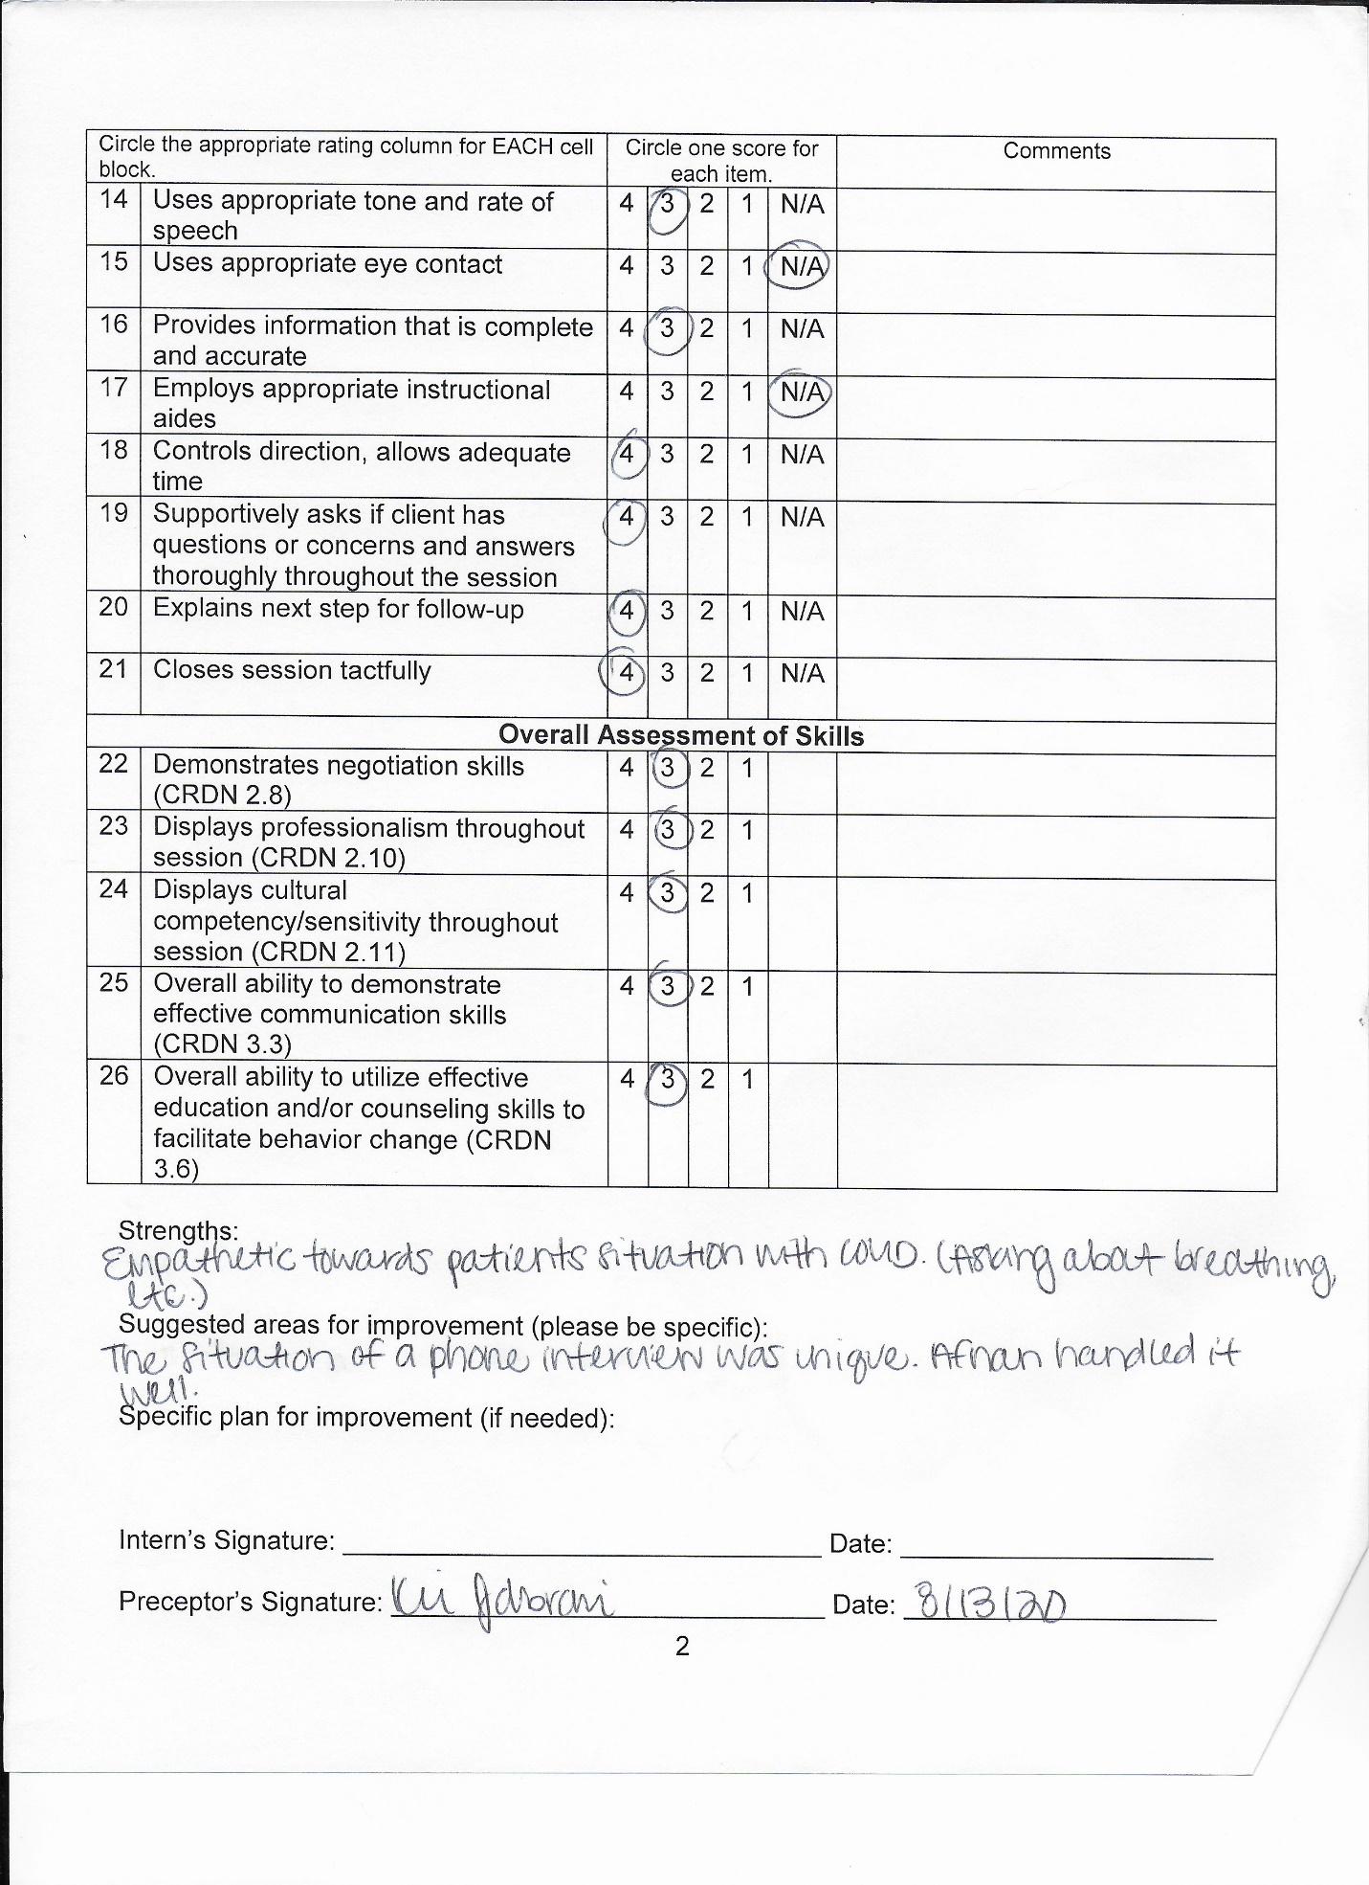
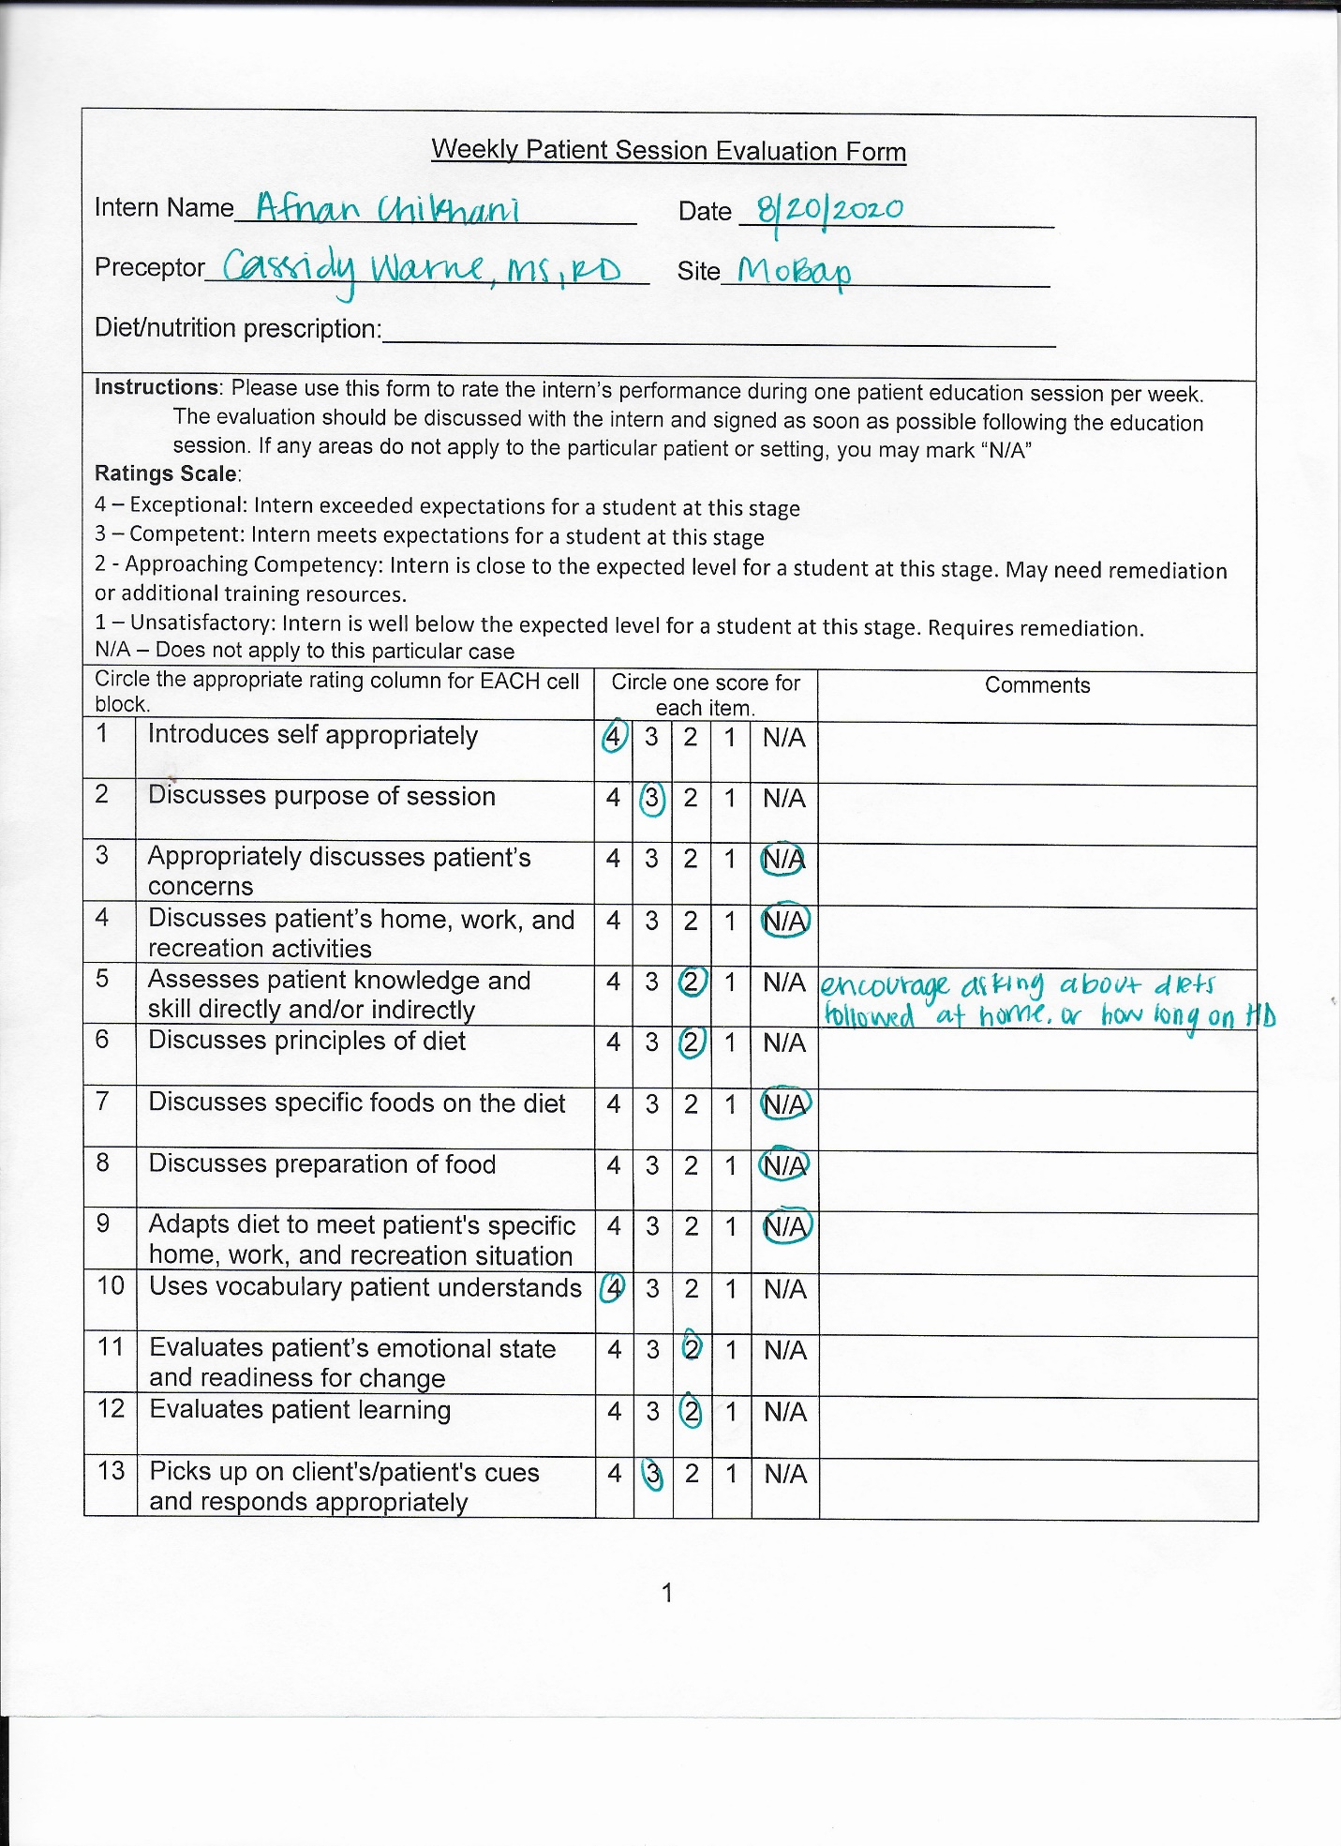
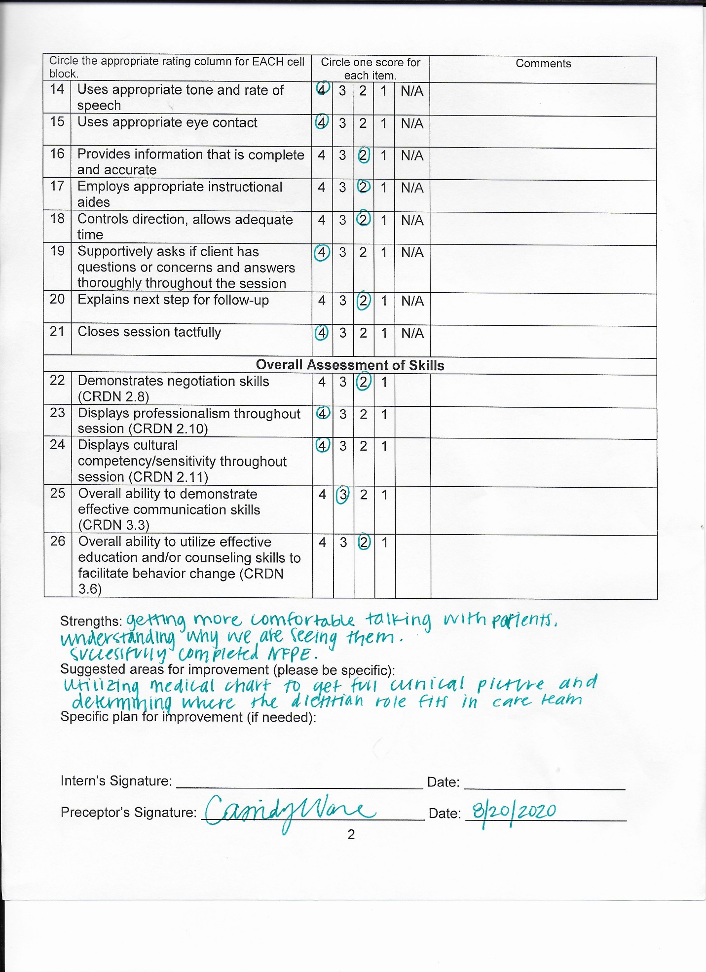
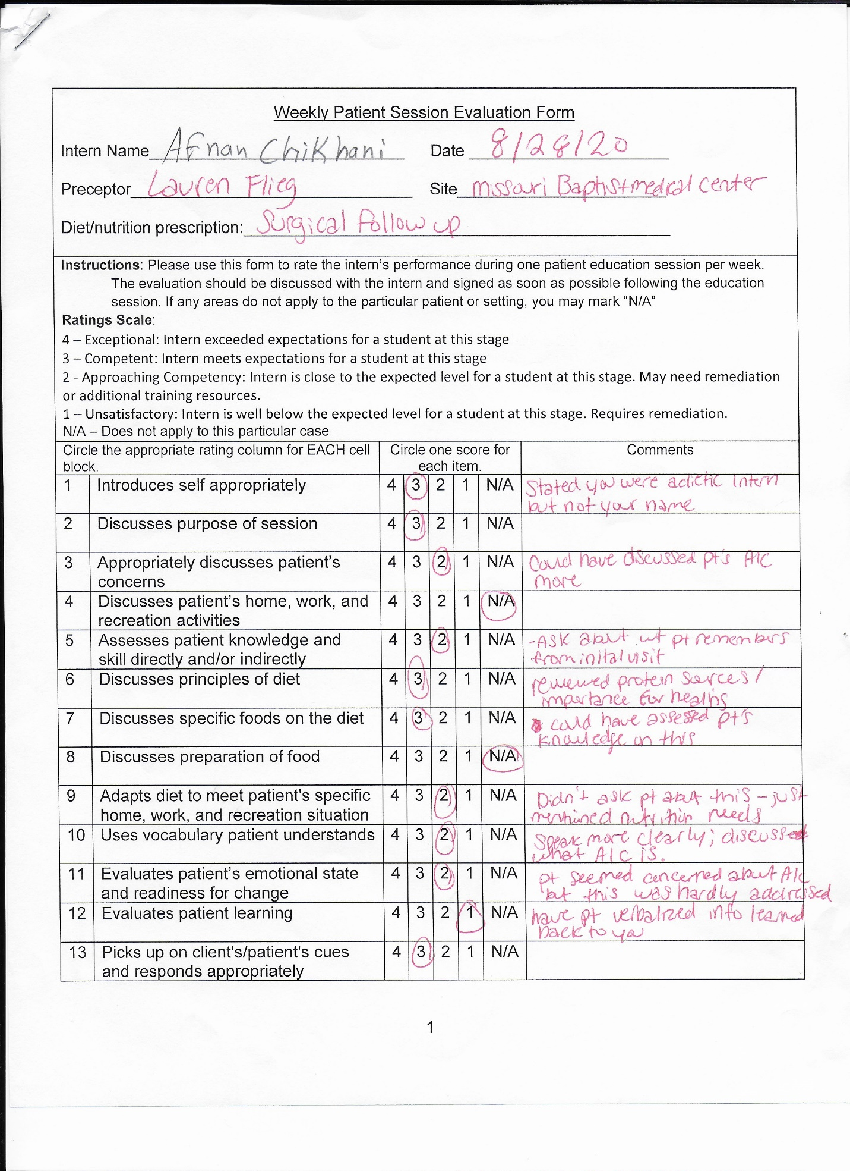
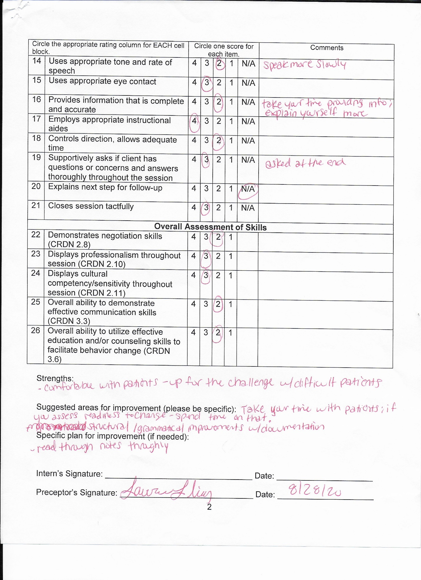
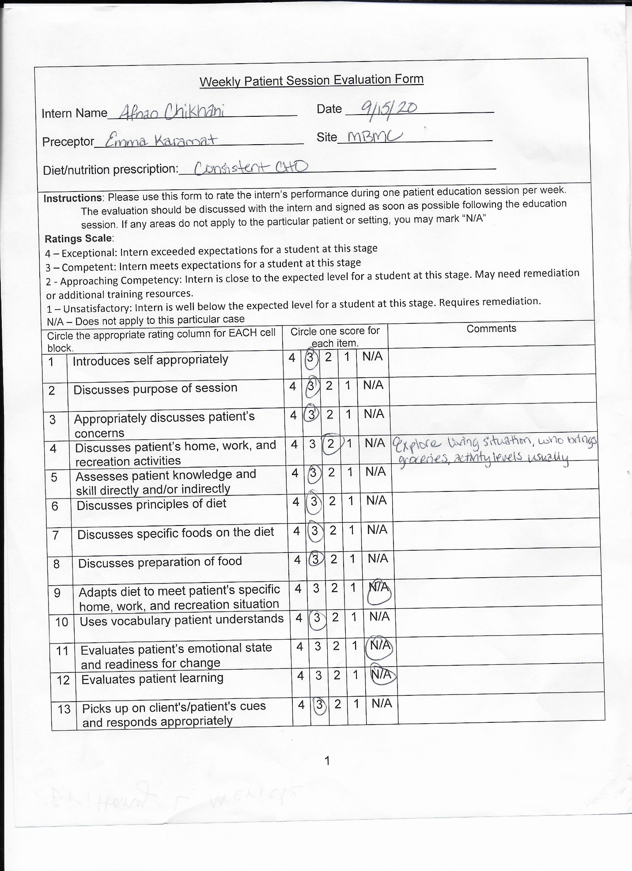
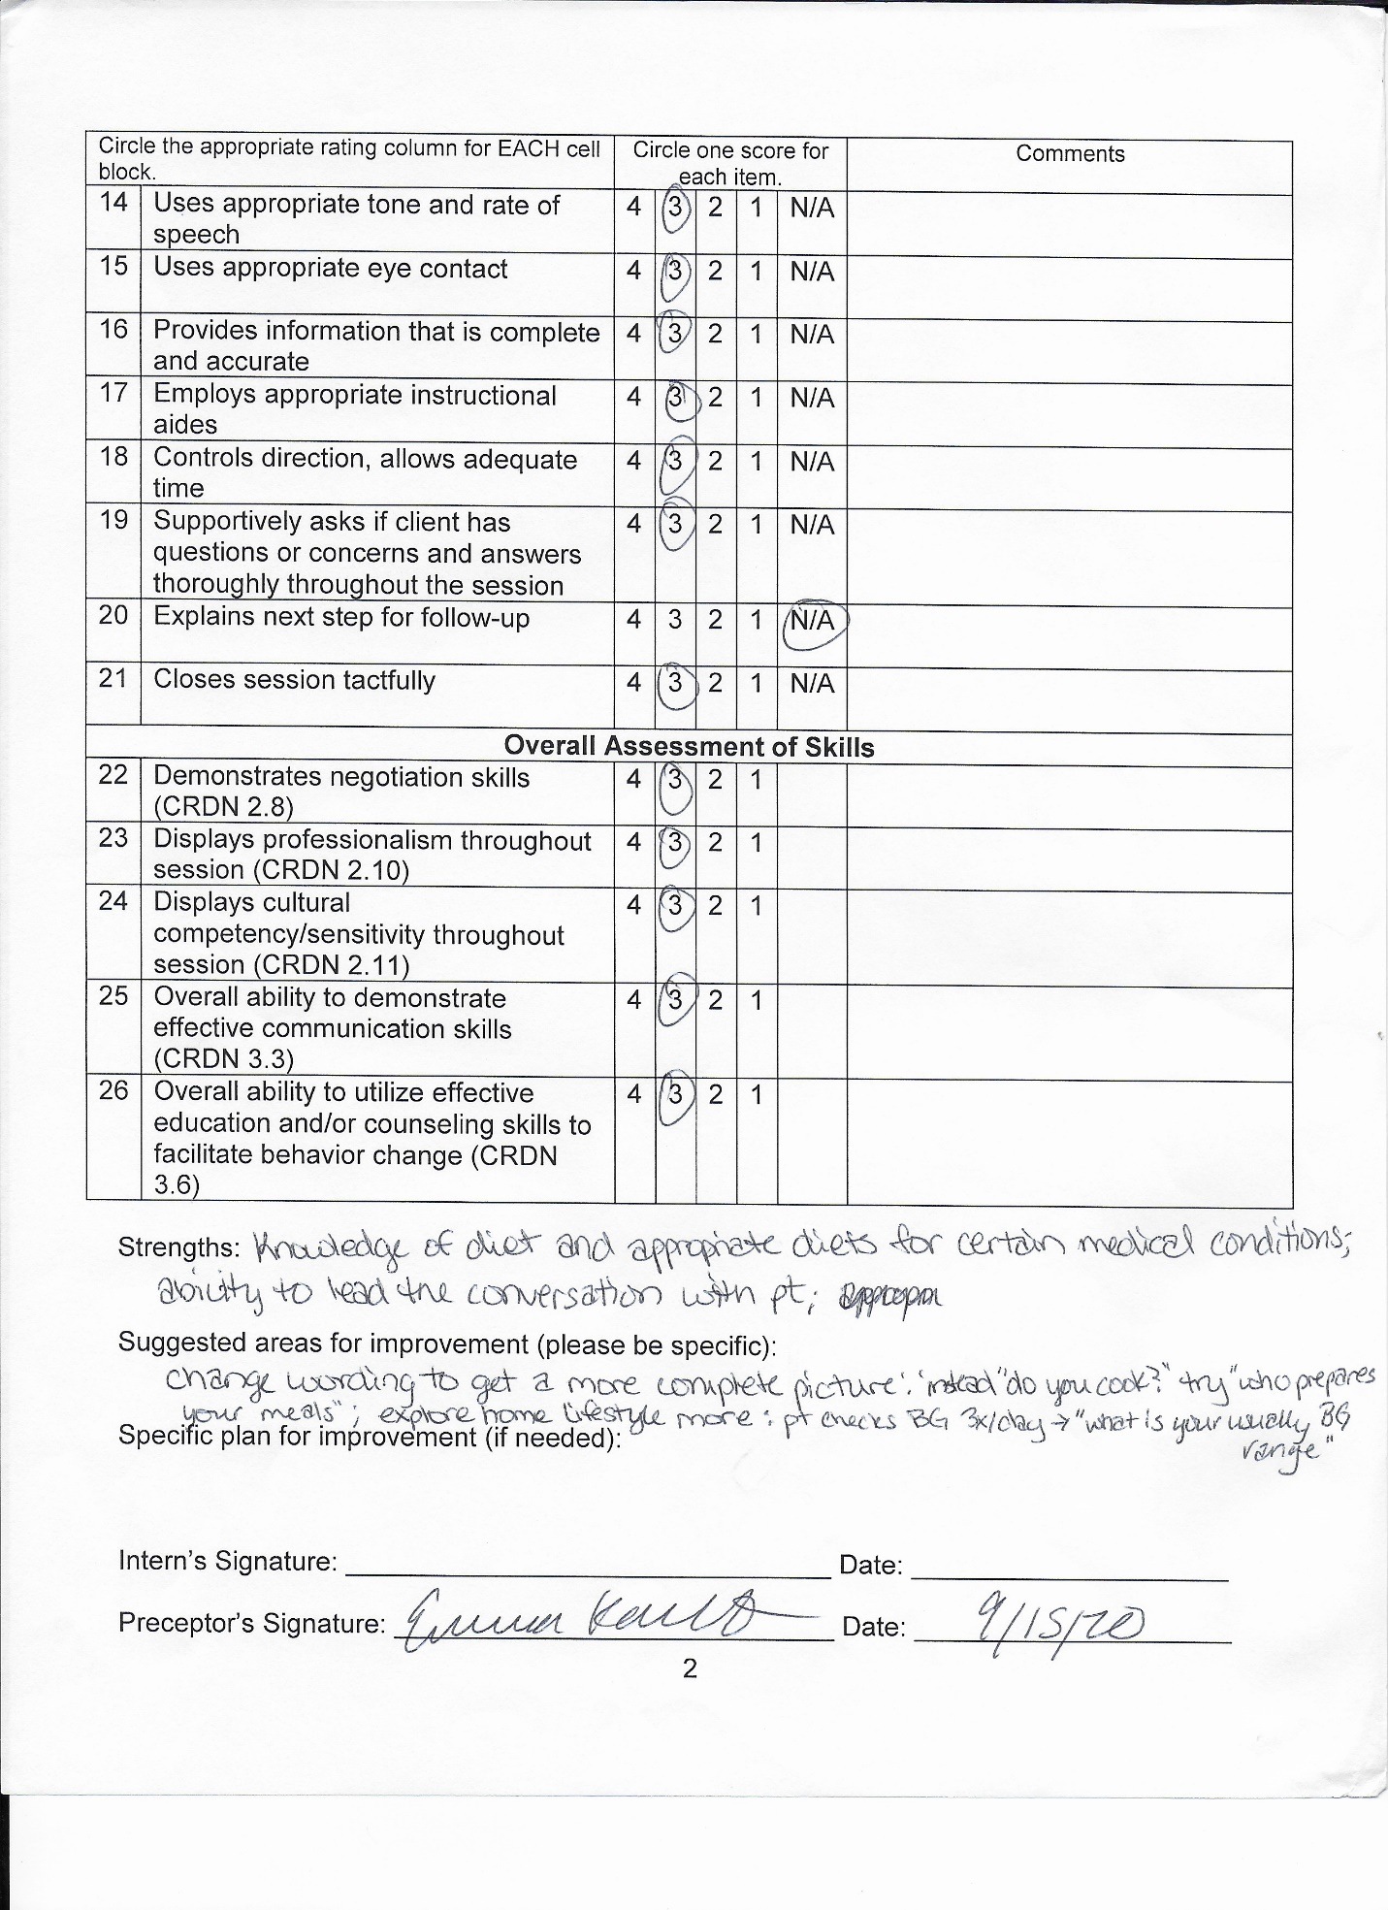
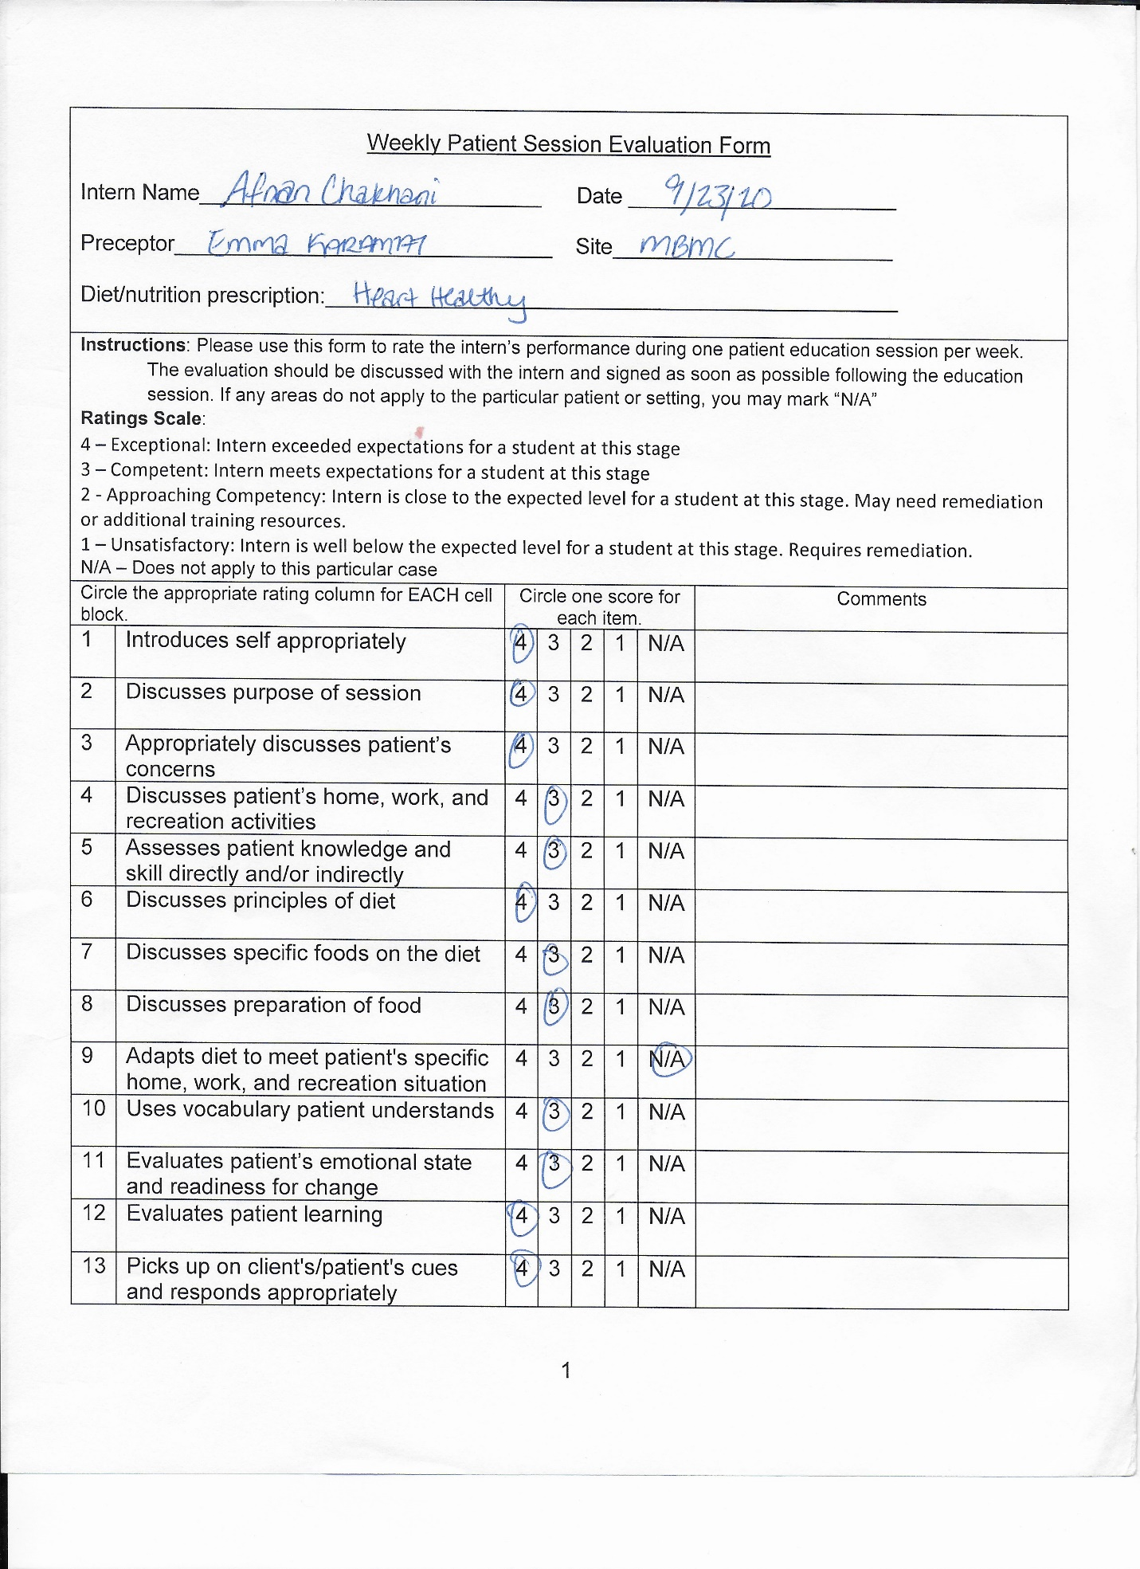
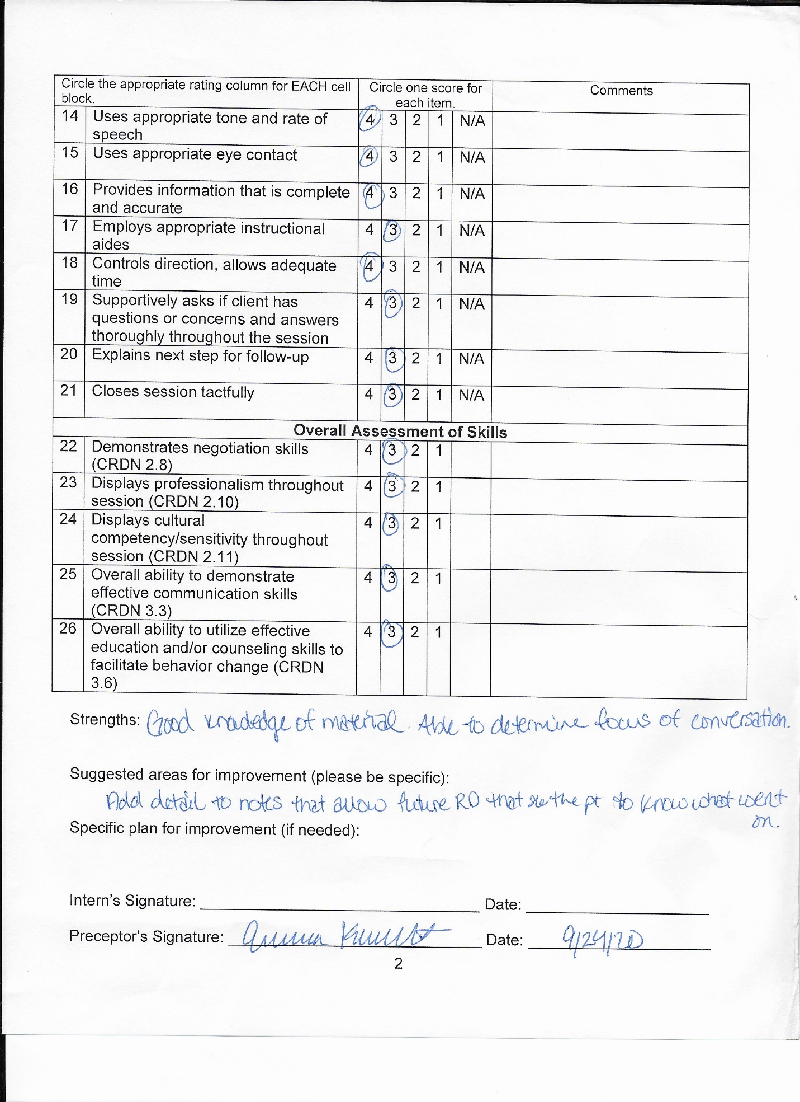
Reflection
My medical rotation was great educational experience. The weekly evaluation acts as a guide for some of the skills I need to build. I practiced the newly learned nutritional therapy as part of the treatments. Medical nutrition therapy is as important for healing as other medical treatments. I also worked on assessment and counseling with inpatient and outpatient setting; specifically, I collected information from patients’ charts and I asked the patients specifics about their diet which directed me to come up with a good treatment plan. I made it a priority always introduce myself and ask for permission to talk to them. After our discussion, I always made sure to close the session by giving them follow up information, my contact information, and wishing them a good day. Additionally, I was able to assess and infer the patient’s level of nutritional knowledge, ranging from not knowing what a calorie is to finding myself consulting a physician. With this inference, I am able to consult them according to their comfortable level.
On my evaluation sheet, the common strengths that my receptors agreed on were the following:
- I have the knowledge of constructing a appropriate diet for certain medical conditions.
- I have the ability to lead the conversation with patients even with challenging cases.
- I can be comfortable when communication to the medical staff such as talking to nurses.
In the beginning of my rotation, I needed to improve on getting more details from the charts, I also had to better my writing a good chart note. I improved a lot on getting details from the electronic medical record and comprehending the conditions of the patients’ case. Furthermore, I got better at writing notes, which proved to be different, since they need to be short and direct while giving all the crucial information. I now write details with as little amount of words as possible because no one has time to read an extensive report. In conclusion, my overall counseling and communication skills improved very much throughout the rotation.

